# Task 1

## Linux installation

Linux is a family of open-source operating systems. They are based on the Linux kernel and are free to download. They can be installed on either a Mac or Windows computer. Here’s how to install Linux on a Windows 10 PC.

#### step 1

**First you have to install VMware Workstation Player from the link below to create virtual machine.**

<https://www.vmware.com/asean/products/workstation-player.html>

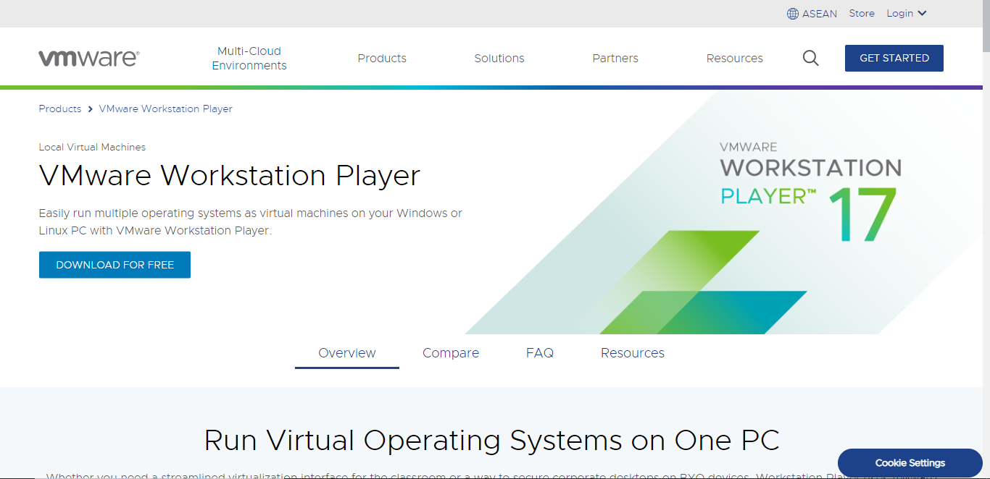

**click on button Download For Free.**

##### **After downloading go to directory where you have download VMware software double click if you're a window user and install like a normal software. Following windows will show.**

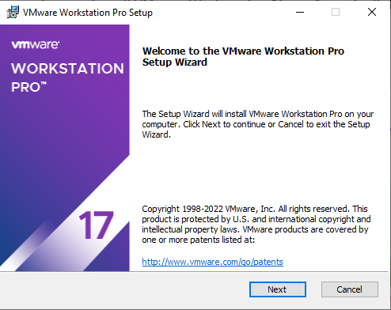

**Click on Next Button**.

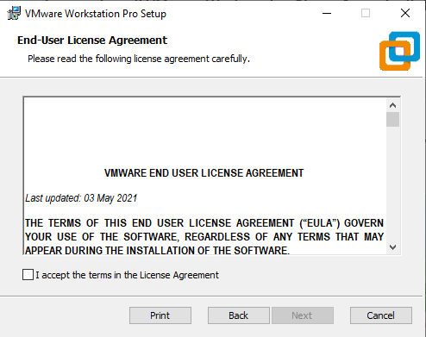

**Accept License and Click on Next.**

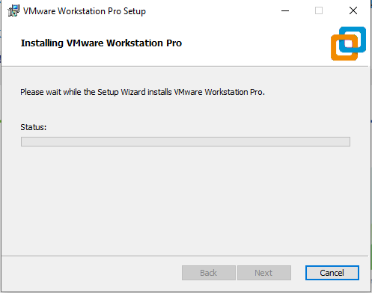

**After completing the following process. VM ware install successfully now we are able to install Ubuntu(Linux) on our computer.**

#### step 2

**Download a Linux distro in ISO format.** An ISO file is a disk image. Some of the top options are [Ubuntu](https://ubuntu.com/download/desktop), [Mint](https://linuxmint.com/download.php), or [Fedora](https://getfedora.org/). They are free to download from each distribution’s main website. For this article, we are using Ubuntu.

**You can Download Ubuntu using link given blow.**

<https://ubuntu.com/desktop>

**After click on this link following window will be appear.**

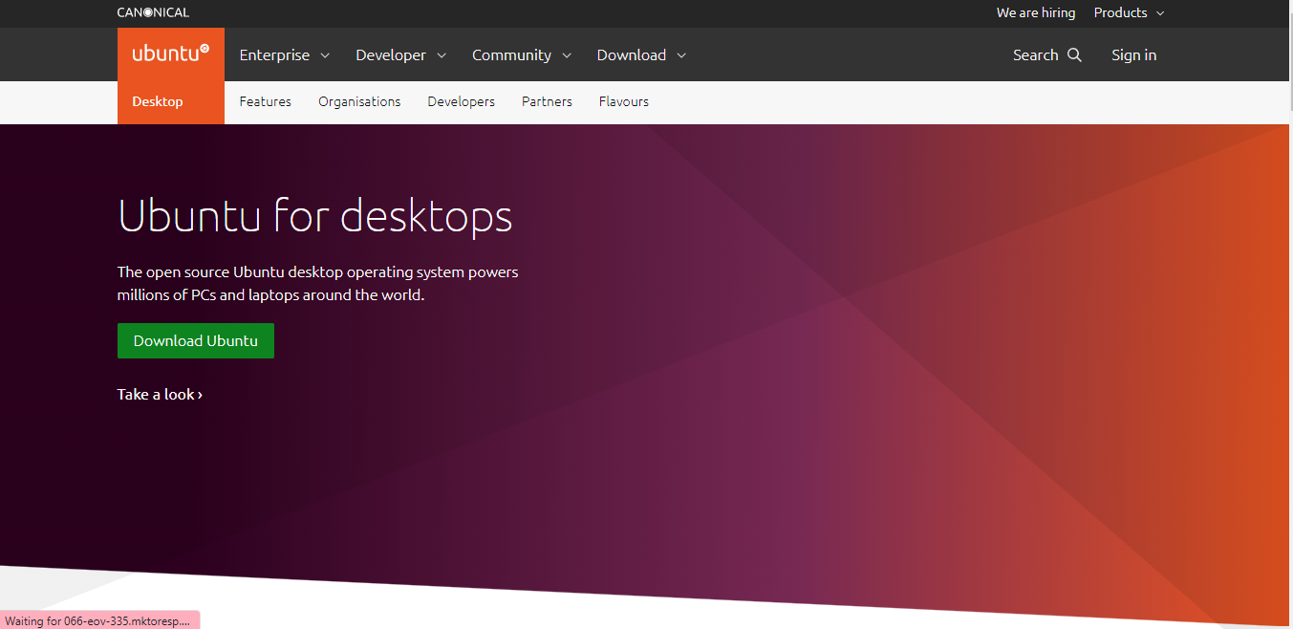

**After downloading all software open VMware and Follow the following Steps. Following windows will be shown.**

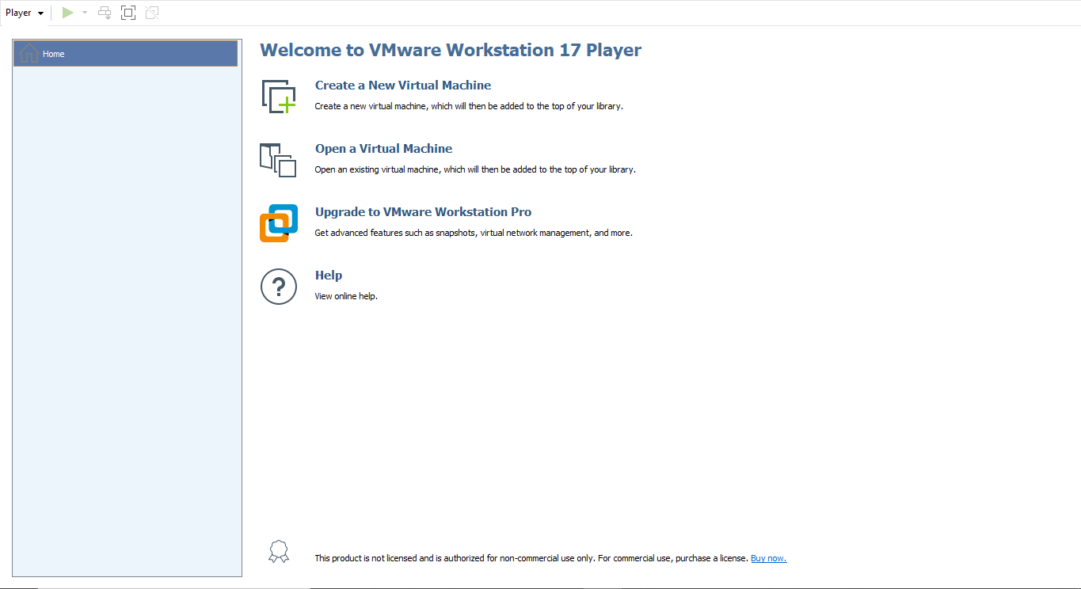

**Click on "Create new Virtual Machine".**

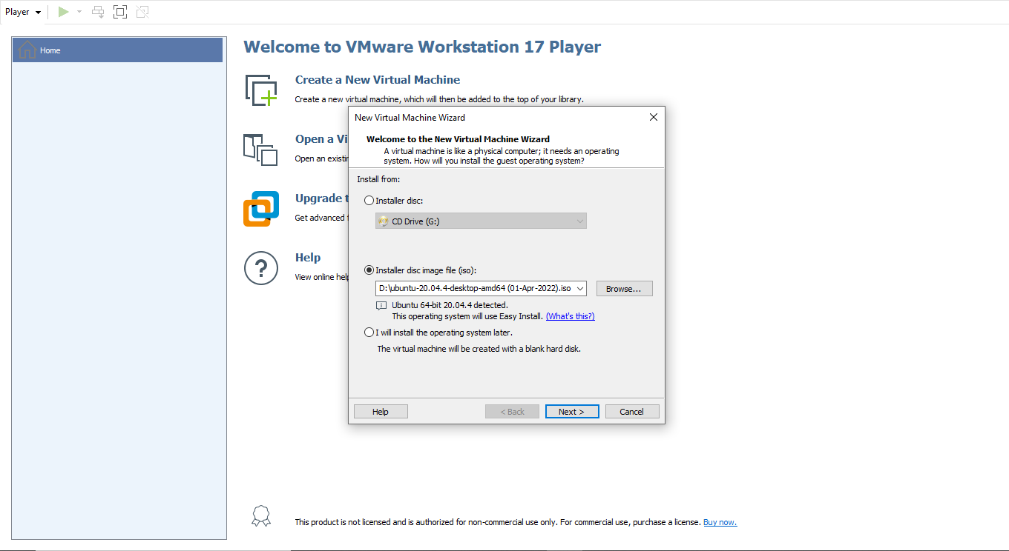

**Click on Button "Next" to continue process.**

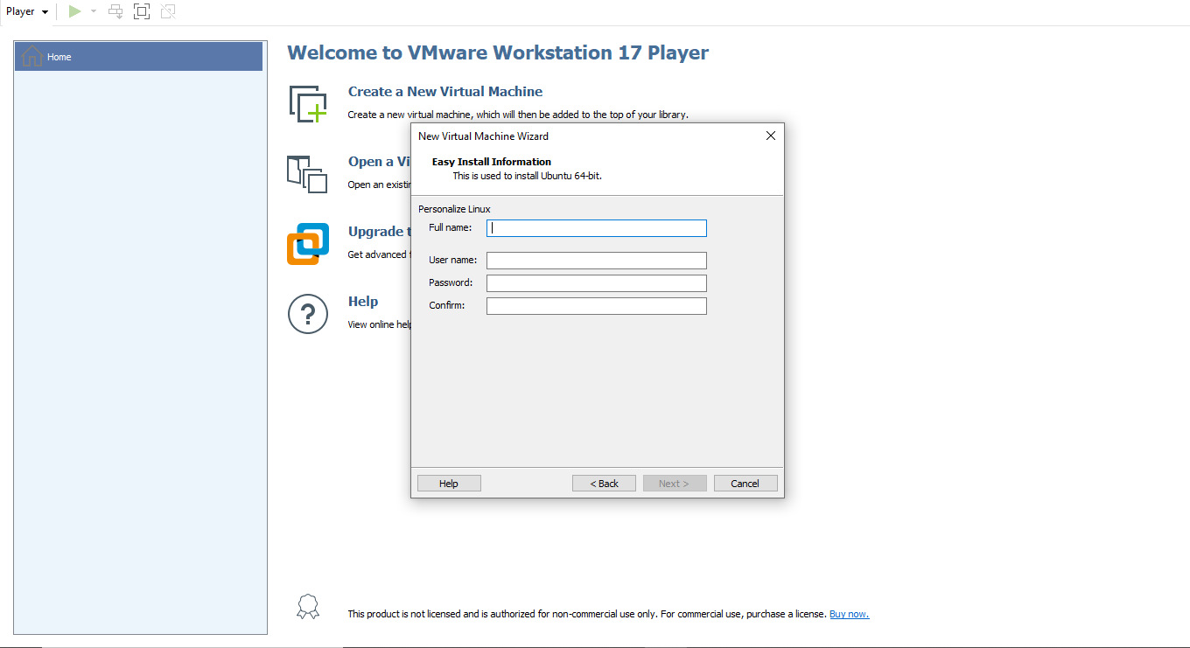

**Enter Full Name ,User Name in lowercase alphabets "abc123" and also enter password and confirm it. this pass will show when we successfully install ubuntu on VM ware.**

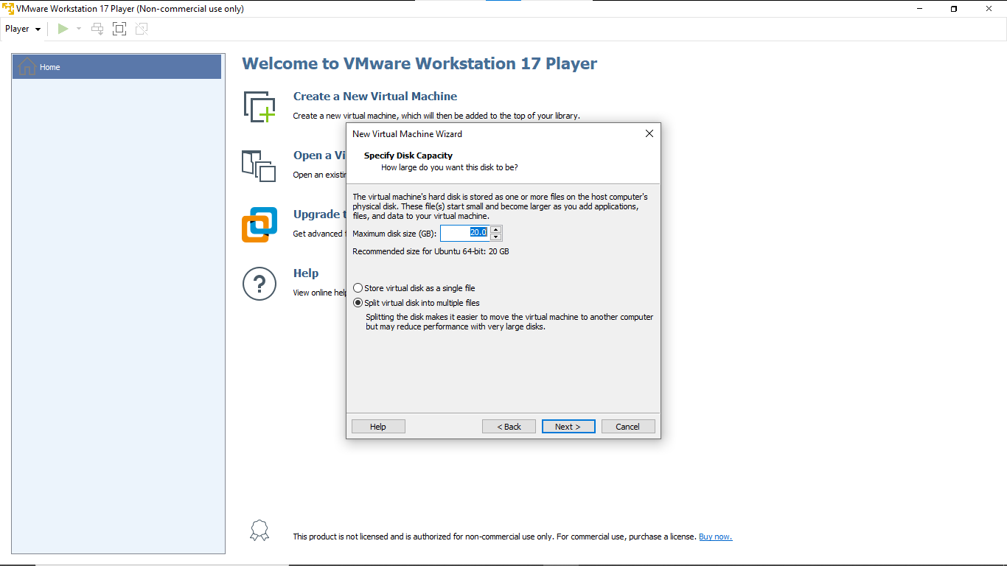

select disk size you want to given to virtual Machine.Then **installation** will start.

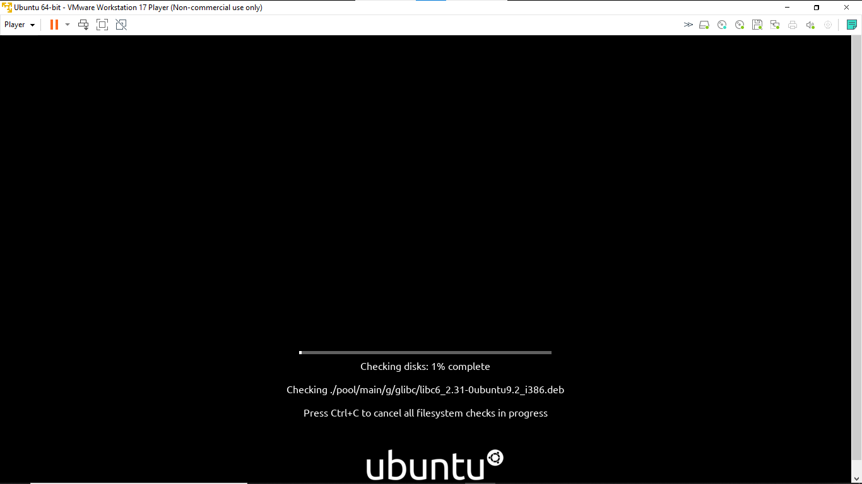

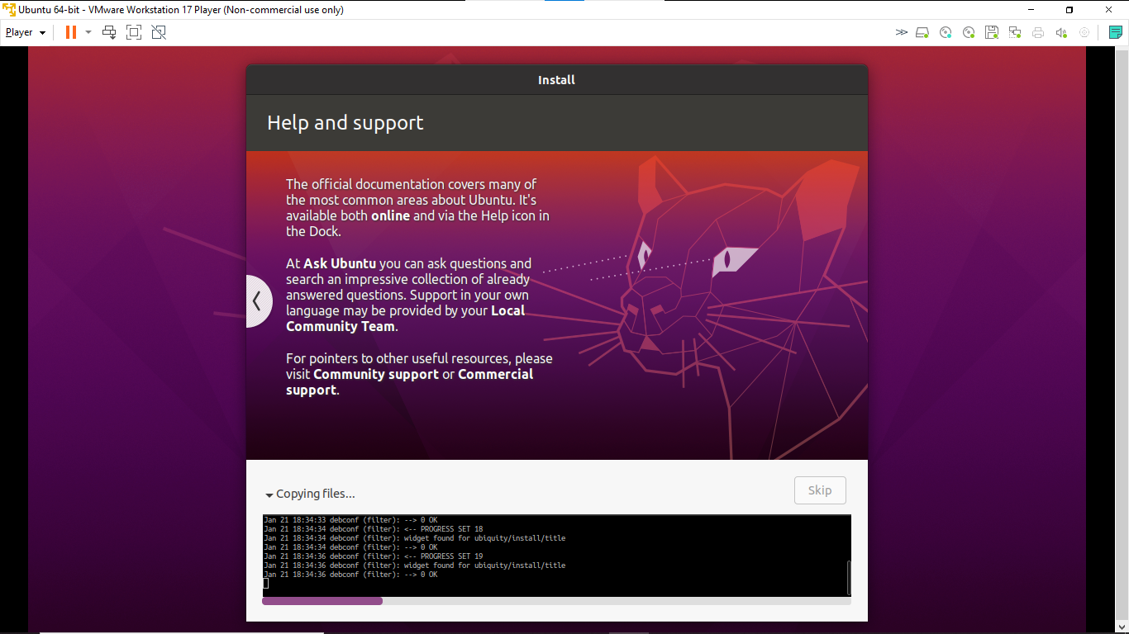

File are copying **Installation is in process.**

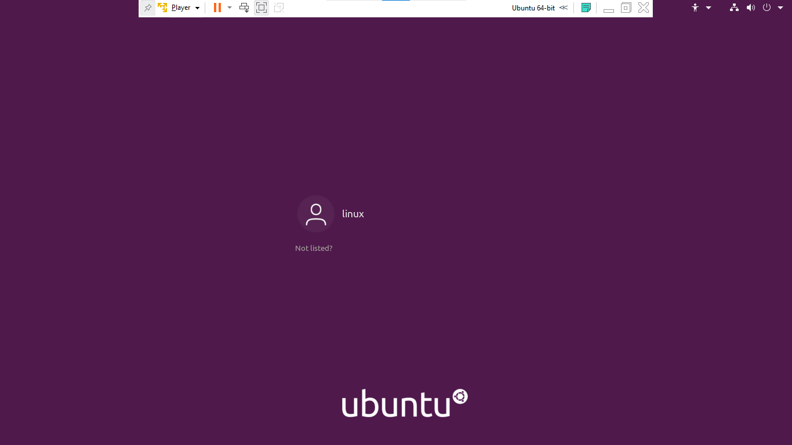

**Installation is completed.** Now we can use Linux on or computer.

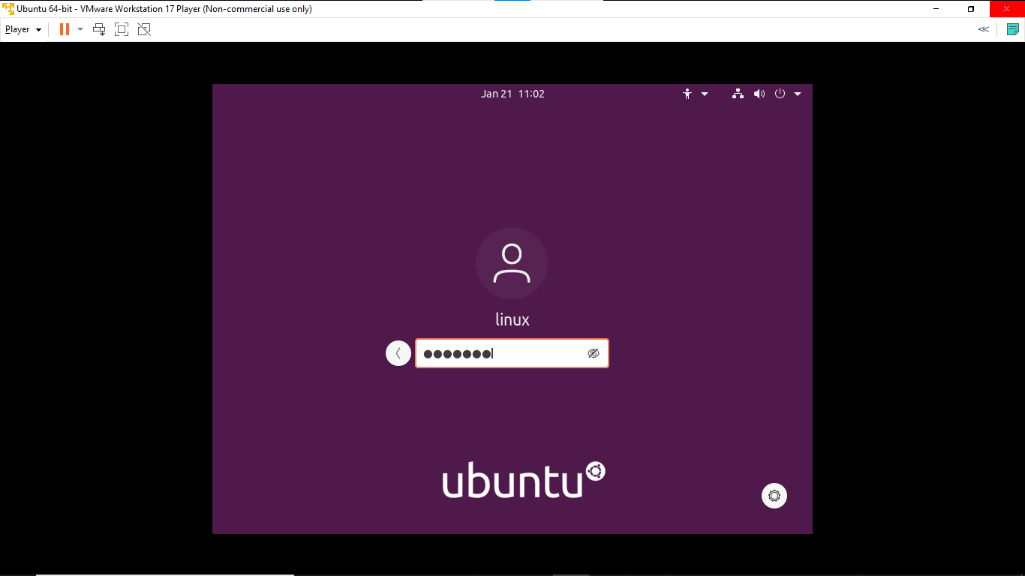

**Enter Password we set in start.** The following windows will appear.

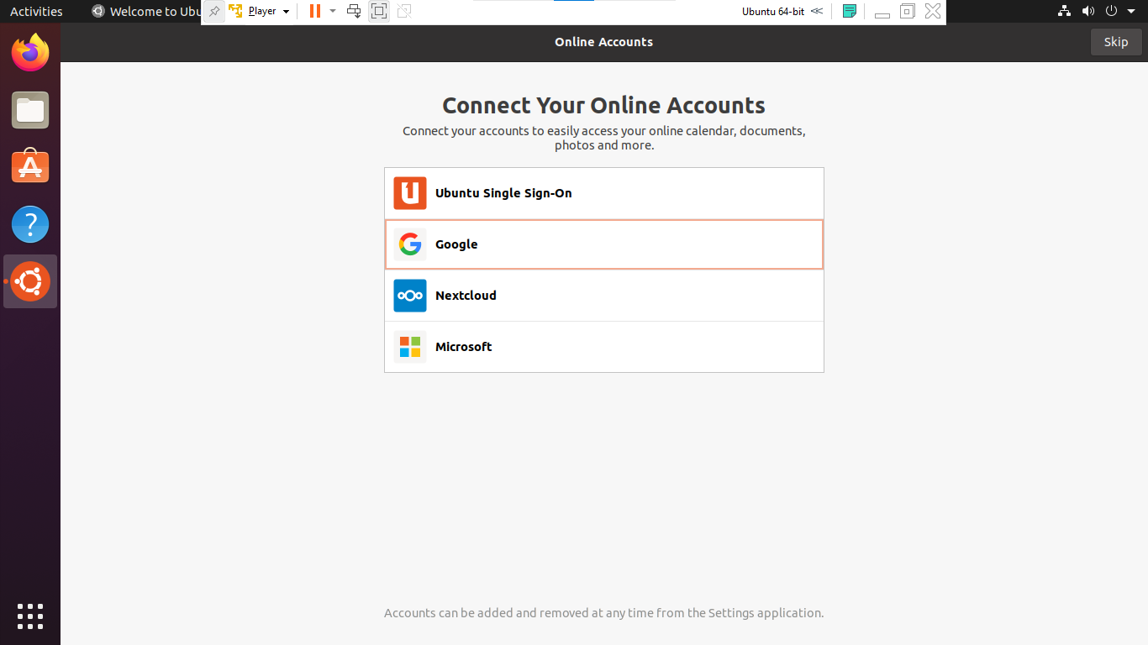

if you want to set any account you can. but you can skip by **Clicking on Top Right "Skip" Button.**

**Now Installation has been completed .**

you can enjoy Linux.

# Task2

After Complete Installation of ubuntu in VMware make any folder using **terminal** or **Right click** as.

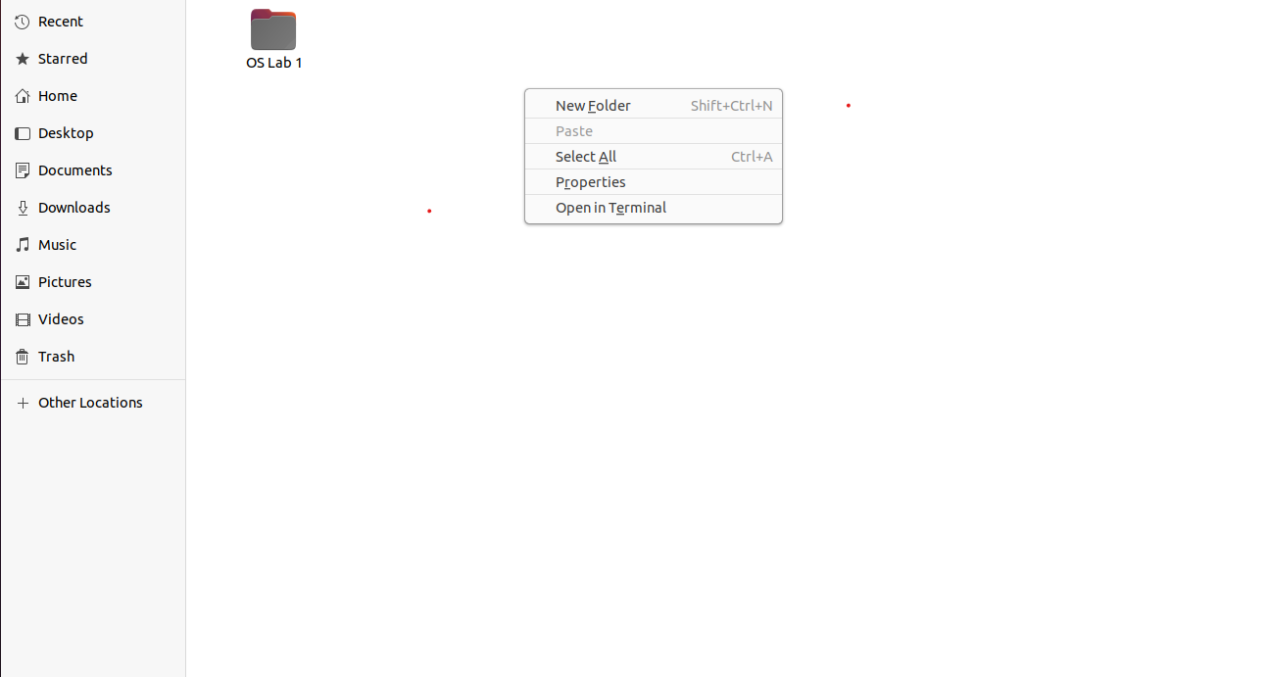

Click on new Folder or press **Shift + Ctrl + N** to create a Folder.

or by Using Terminal you can also create Folder as Follow.

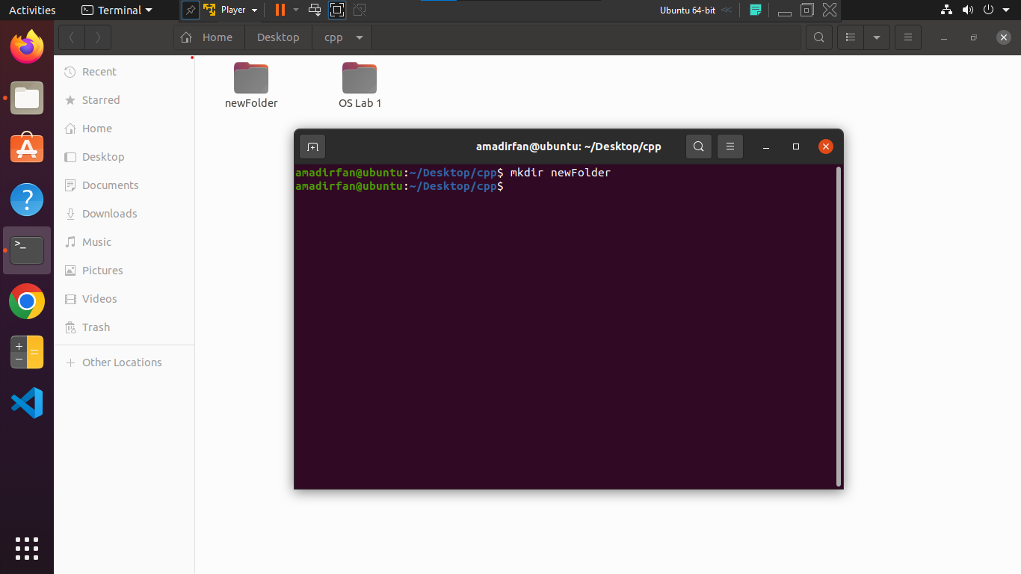

by using command

mkdir FolderName

New folder will be create.

Now open previously created Folder and create a **.cpp** file using Terminal as.



by clicking on **Open in Terminal** current folder will be open in terminal.

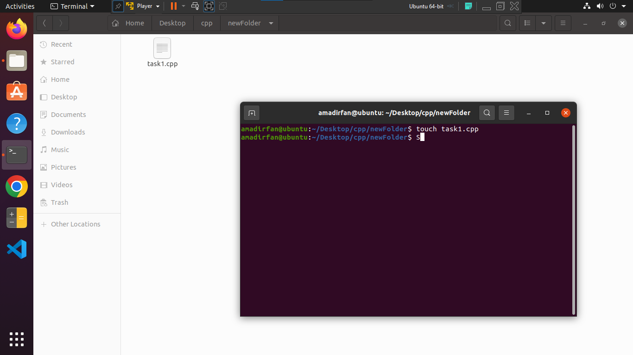

run **touch task1.cpp** command to create a .cpp file.

touch task1.cpp

file was created. To open or edit you can use different commands such as **gedit** ,**nano** for opening a editor.

nano

gedit

After Writing your required code press **ctrl + S**  to save code.

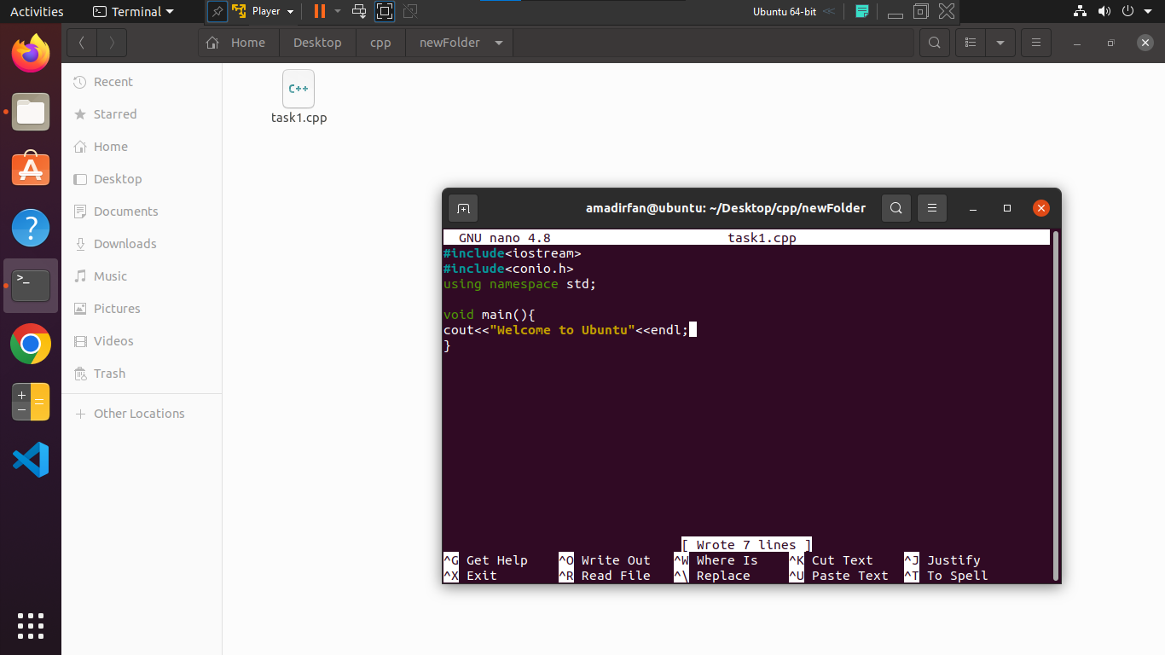

After this run a command to convert it to source code.

g++ task1 -o t

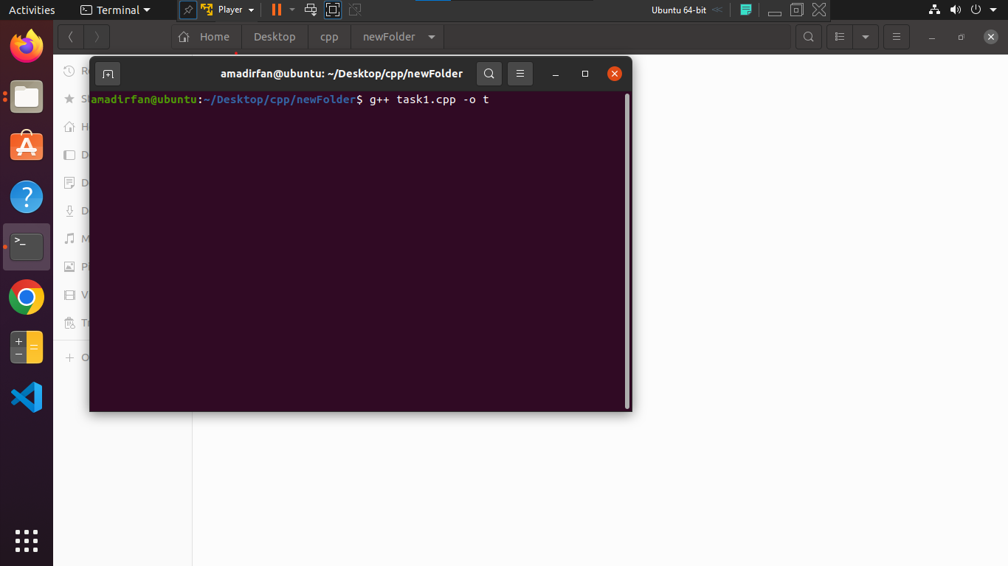

Your code will be compile. If you face any error related to code review your code and run this code again.

to open this file run this command.

./file

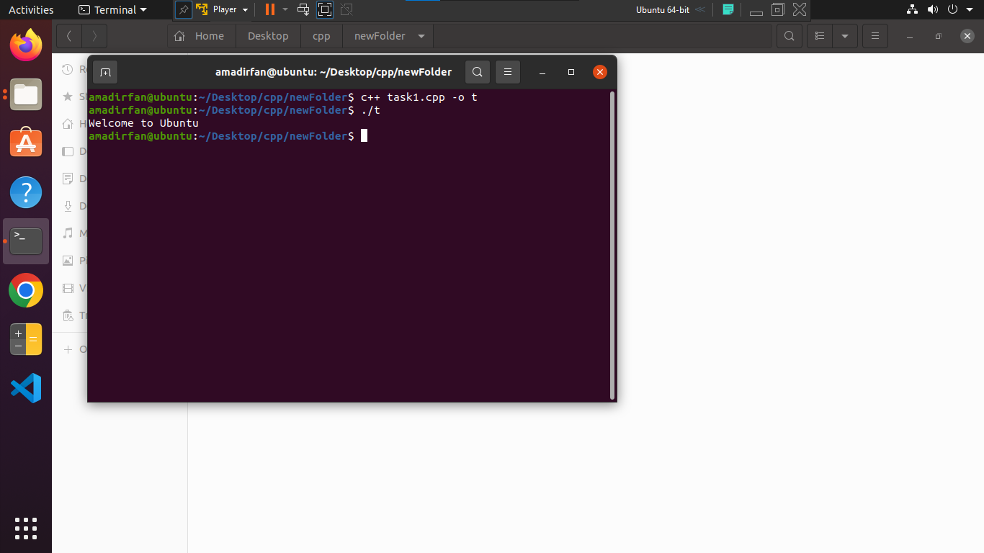

**If you want to create all types of file like .io , .exe or .iso type "g++ filename --save-temps".** Run this command.

g++ like--save-temps

If g++ not working then type **"sudo apt install g++"** or **"sudo apt update "** or simply update your ubuntu it will remove all errors. For that type **"sudo apt install build-essentials ".**

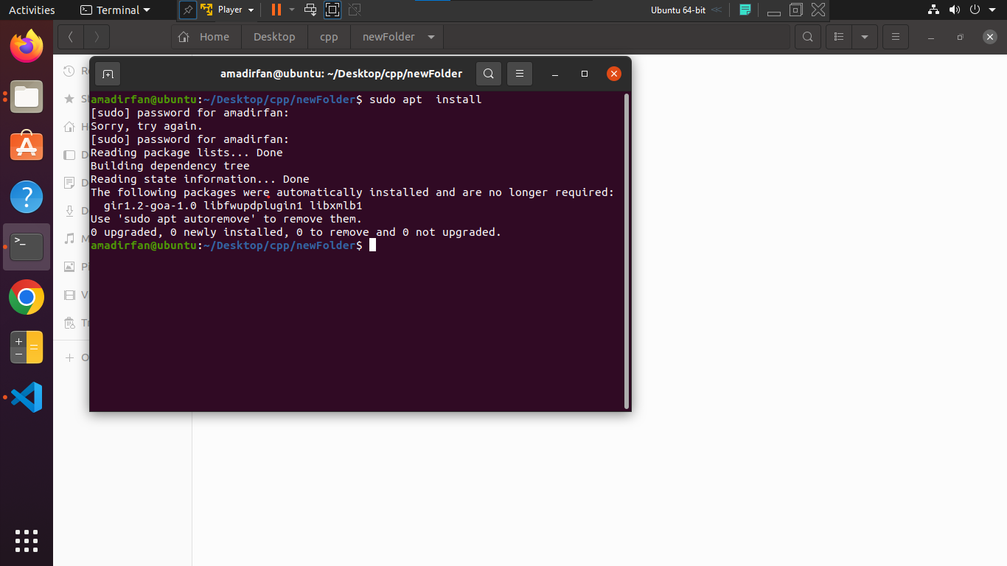

sudo apt update  
or  
sudo apt upgrade

next command.

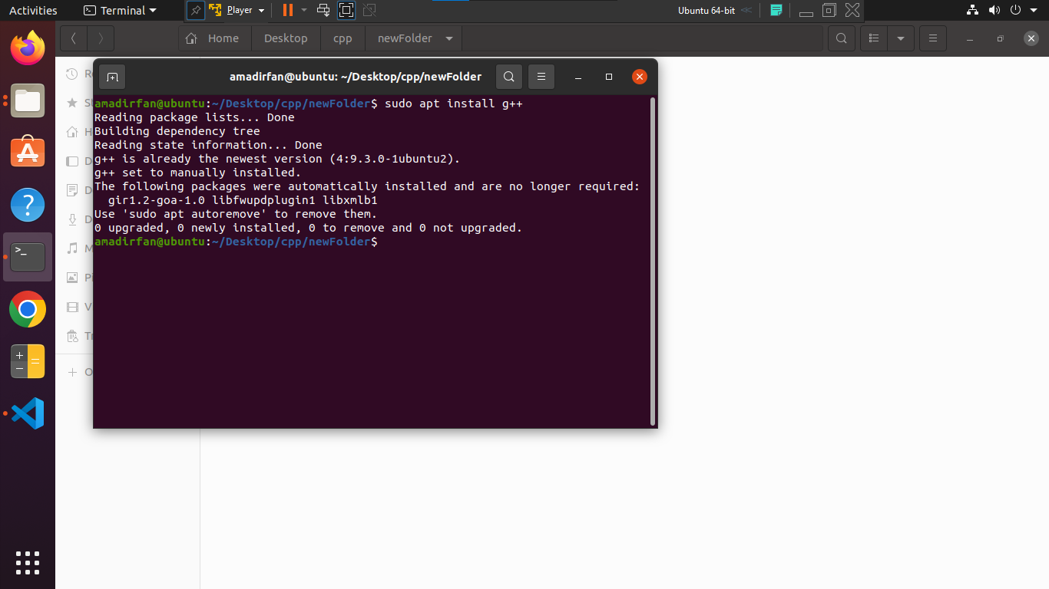

sudo apt install g++

next command.

sudo apt install build-essentials

your g++ module will install successfully.

### Thanks.